**University of North Texas**

**Denton, Texas**

**Computer Science**

**CSCE 5350(Section -006) – Fundamentals of Database Systems**

# **Online Multi-Vendor Marketplace System**

1.Introduction

2. Goals and Scope

3. Updated ER-Diagram

4. ER Mapping

5. Normalization

6. SQL statements to create tables

7. Sample Data Screenshots

8.Functional Requirements and Queries

9.Steps for running the system

10. UI Screenshots

**1. Introduction**

The Online Multi-vendor Marketplace System (OMVMS) resembles a cutting-edge shopping center platform online. It's where numerous merchants can settle in to sell their things, and individuals who need to purchase can undoubtedly buy various items. Sellers can easily deal with their products, and purchasers can make accounts, track their orders, and make secure buys. The framework keeps everything coordinated, from the amount of an item available and it also incorporates what customers think in reviews. There's even a way for vendors to publicize their items on the platform. The framework is intended to be easy to utilize, safe, and can develop as additional users participate. The diagram shows how everything, from vendors to products and customers, is associated with making the framework work smoothly.

**2. Goals and Scope**.  
The goal of the online Multi-vendor Marketplace System (OMVMS) is to give a user-friendly and safe platform where merchants can list and sell products, and clients can easily browse and make buys. The project intends to change the Internet shopping experience by encouraging a powerful commercial center that focuses on versatility and data integrity.

3. **Updated ER-diagram**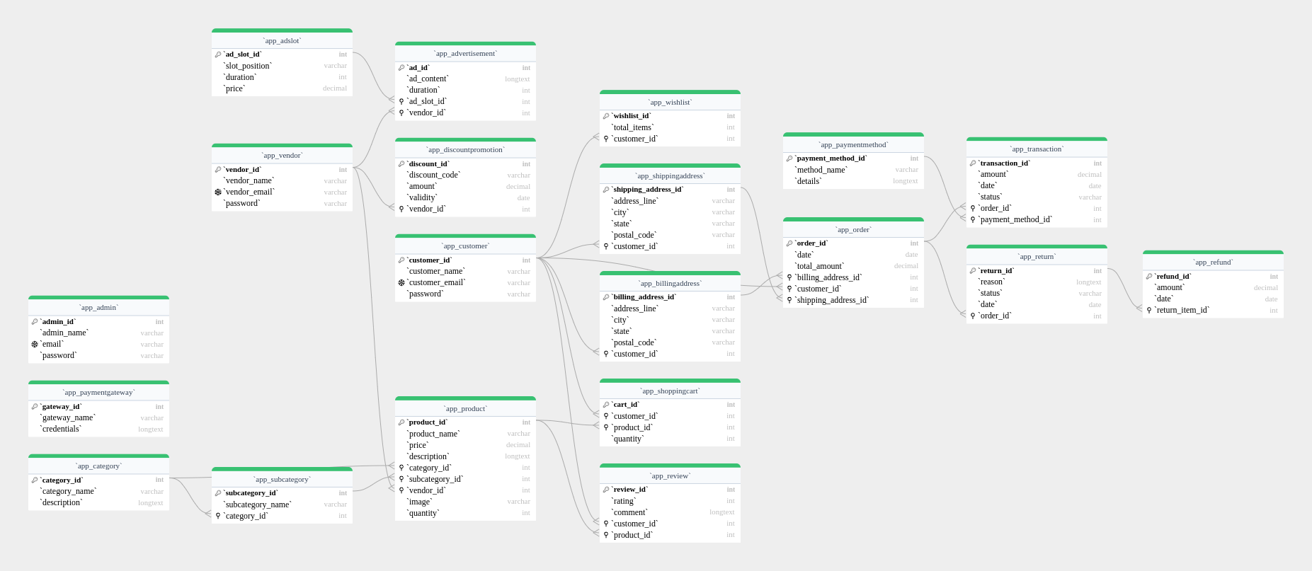

**4. ER mapping**1. Vendor Table:

- Attributes:

- `vendor_id` (AutoField, Primary Key)

- `vendor_name` (CharField)

- `vendor_email` (EmailField)

- `password` (CharField)

2. Customer Table:

- Attributes:

- `customer_id` (AutoField, Primary Key)

- `customer_name` (CharField)

- `customer_email` (EmailField)

- `password` (CharField)

3. Admin Table:

- Attributes:

- `admin_id` (AutoField, Primary Key)

- `admin_name` (CharField)

- `email` (EmailField)

- `password` (CharField)

4. Category Table:

- Attributes:

- `category_id` (AutoField, Primary Key)

- `category_name` (CharField)

- `description` (TextField)

5. SubCategory Table:

- Attributes:

- `subcategory_id` (AutoField, Primary Key)

- `category` (ForeignKey to Category)

- `subcategory_name` (CharField)

6. Product Table:

- Attributes:

- `product_id` (AutoField, Primary Key)

- `vendor` (ForeignKey to Vendor)

- `category` (ForeignKey to Category)

- `subcategory` (ForeignKey to SubCategory)

- `product_name` (CharField)

- `price` (DecimalField)

- `description` (TextField)

- `quantity` (IntegerField)

- `image` (ImageField)

7. Order Table:

- Attributes:

- `order_id` (AutoField, Primary Key)

- `customer` (ForeignKey to Customer)

- `shipping_address` (ForeignKey to ShippingAddress)

- `billing_address` (ForeignKey to BillingAddress)

- `date` (DateField)

- `total_amount` (DecimalField)

8. Transaction Table:

- Attributes:

- `transaction_id` (AutoField, Primary Key)

- `order` (ForeignKey to Order)

- `payment_method` (ForeignKey to PaymentMethod)

- `amount` (DecimalField)

- `date` (DateField)

- `status` (CharField)

9. Review Table:

- Attributes:

- `review_id` (AutoField, Primary Key)

- `product` (ForeignKey to Product)

- `customer` (ForeignKey to Customer)

- `rating` (IntegerField)

- `comment` (TextField)

10. Advertisement Table:

- Attributes:

- `ad_id` (AutoField, Primary Key)

- `vendor` (ForeignKey to Vendor)

- `ad_slot` (ForeignKey to AdSlot)

- `ad_content` (TextField)

- `duration` (IntegerField)

11. PaymentGateway Table

- Attributes:

- `gateway_id` (AutoField, Primary Key)

- `gateway_name` (CharField)

- `credentials` (TextField)

12. ShoppingCart Table:

- Attributes:

- `cart_id` (AutoField, Primary Key)

- `customer` (ForeignKey to Customer)

- `product` (ForeignKey to Product)

- `quantity` (PositiveIntegerField)

13. Wishlist Table:

- Attributes:

- `wishlist_id` (AutoField, Primary Key)

- `customer` (ForeignKey to Customer)

- `total_items` (IntegerField)

14. PaymentMethod Table:

- Attributes:

- `payment_method_id` (AutoField, Primary Key)

- `method_name` (CharField)

- `details` (TextField)

15. ShippingAddress Table:

- Attributes:

- `shipping_address_id` (AutoField, Primary Key)

- `customer` (ForeignKey to Customer)

- `address_line` (CharField)

- `city` (CharField)

- `state` (CharField)

- `postal_code` (CharField)

16.BillingAddress Table:

- Attributes:

- `billing_address_id` (AutoField, Primary Key)

- `customer` (ForeignKey to Customer)

- `address_line` (CharField)

- `city` (CharField)

- `state` (CharField)

- `postal_code` (CharField)

17. Return Table:

- Attributes:

- `return_id` (AutoField, Primary Key)

- `order` (ForeignKey to Order)

- `reason` (TextField)

- `status` (CharField)

- `date` (DateField)

18. Refund Table:

- Attributes:

- `refund_id` (AutoField, Primary Key)

- `return_item` (ForeignKey to Return)

- `amount` (DecimalField)

- `date` (DateField)

19. AdSlot Table:

- Attributes:

- `ad_slot_id` (AutoField, Primary Key)

- `slot_position` (CharField)

- `duration` (IntegerField)

- `price` (DecimalField)

20. DiscountPromotion Table:

- Attributes:

- `discount_id` (AutoField, Primary Key)

- `vendor` (ForeignKey to Vendor)

- `discount_code` (CharField)

- `amount` (DecimalField)

- `validity` (DateField)

**5.Normalization  
Functional Dependencies:**

* + **app_admin**: No apparent issues.
  + **app_adslot**: No apparent issues.
  + **app_advertisement**: Dependent on **ad_slot_id** and **vendor_id**.
  + **app_billingaddress**: Dependent on **customer_id**.
  + **app_customer**: No apparent issues.
  + **app_discountpromotion**: Dependent on **vendor_id**.
  + **app_order**: Dependent on **billing_address_id**, **customer_id**, and **shipping_address_id**.
  + **app_paymentgateway**: No apparent issues.
  + **app_paymentmethod**: No apparent issues.
  + **app_product**: Dependent on **category_id**, **subcategory_id**, and **vendor_id**.
  + **app_refund**: Dependent on **return_item_id**.
  + **app_return**: Dependent on **order_id**.
  + **app_review**: Dependent on **customer_id** and **product_id**.
  + **app_shippingaddress**: Dependent on **customer_id**.
  + **app_shoppingcart**: Dependent on **customer_id** and **product_id**.
  + **app_subcategory**: Dependent on **category_id**.
  + **app_transaction**: Dependent on **order_id** and **payment_method_id**.
  + **app_vendor**: No apparent issues.
  + **app_wishlist**: Dependent on **customer_id**.

**Normalization Steps:**

1. **First Normal Form (1NF):** Ensure all atomic values.
2. **Second Normal Form (2NF):** Remove partial dependencies.
3. **Third Normal Form (3NF):** Eliminate transitive dependencies.

**Normalized Tables:**

1. Customer Information:

* **app_customer**:
  + **customer_id** (PK)
  + **customer_name**
  + **customer_email**
  + **password**

2. Address Information:

* **app_address**:
  + **address_id** (PK)
  + **address_line**
  + **city**
  + **state**
  + **postal_code**
  + **customer_id** (FK to **app_customer**)

3. Order Information:

* **app_order**:
  + **order_id** (PK)
  + **date**
  + **total_amount**
  + **billing_address_id** (FK to **app_address**)
  + **shipping_address_id** (FK to **app_address**)
  + **customer_id** (FK to **app_customer**)

4. Product Information:

* **app_product**:
  + **product_id** (PK)
  + **product_name**
  + **price**
  + **description**
  + **category_id** (FK to **app_category**)
  + **subcategory_id** (FK to **app_subcategory**)
  + **vendor_id** (FK to **app_vendor**)
  + **image**
  + **quantity**

5. Advertisement Information:

* **app_advertisement**:
  + **ad_id** (PK)
  + **ad_content**
  + **duration**
  + **ad_slot_id** (FK to **app_adslot**)
  + **vendor_id** (FK to **app_vendor**)

6. Payment Information:

* **app_payment**:
  + **payment_id** (PK)
  + **amount**
  + **date**
  + **order_id** (FK to **app_order**)
  + **payment_method_id** (FK to **app_paymentmethod**)

7. Review Information:

* **app_review**:
  + **review_id** (PK)
  + **rating**
  + **comment**
  + **customer_id** (FK to **app_customer**)
  + **product_id** (FK to **app_product**)

8. Wishlist Information:

* **app_wishlist**:
  + **wishlist_id** (PK)
  + **total_items**
  + **customer_id** (FK to **app_customer**)

These tables aim to minimize redundancy and maintain data integrity by splitting data logically based on functional dependencies.

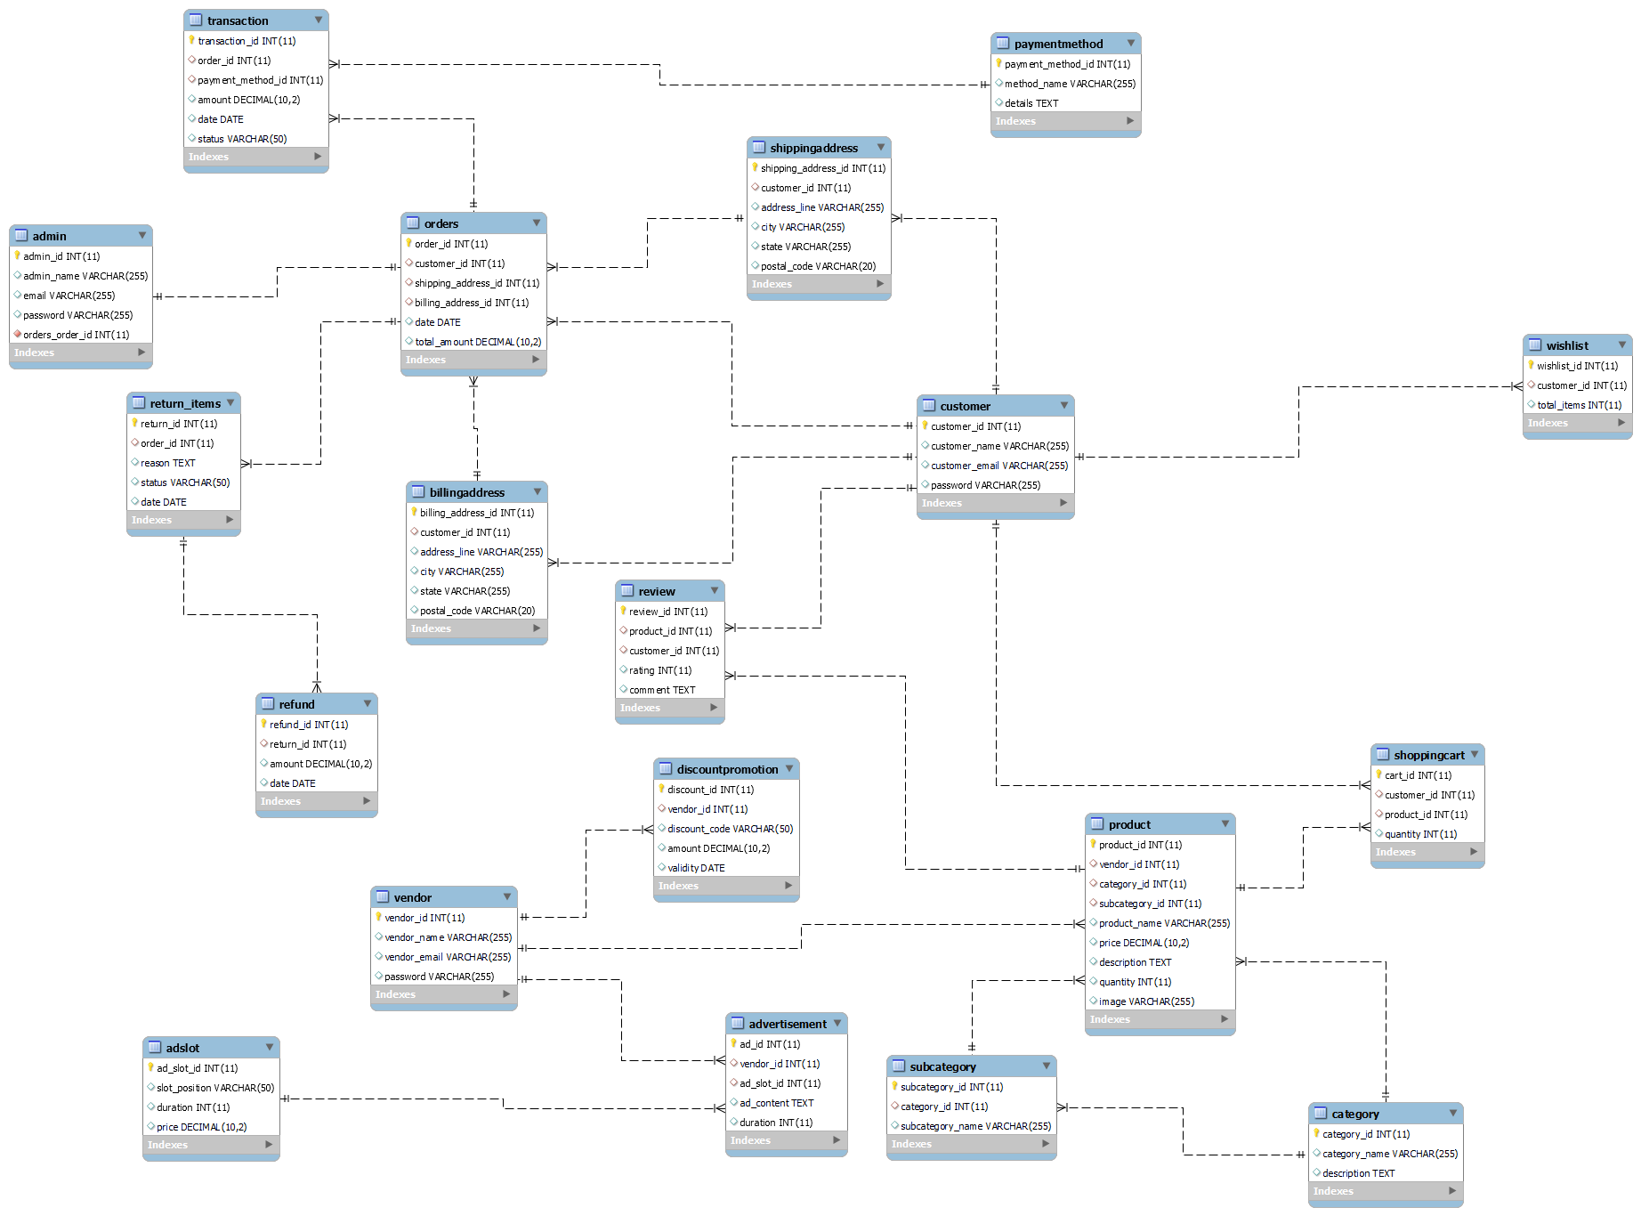

**6.SQL statements to create table**-- Create Vendor Table

CREATE TABLE vendor (

vendor_id SERIAL PRIMARY KEY,

vendor_name VARCHAR(255),

vendor_email VARCHAR(255) UNIQUE,

password VARCHAR(255)

);

-- Create Customer Table

CREATE TABLE customer (

customer_id SERIAL PRIMARY KEY,

customer_name VARCHAR(255),

customer_email VARCHAR(255) UNIQUE,

password VARCHAR(255)

);

-- Create Admin Table

CREATE TABLE admin (

admin_id SERIAL PRIMARY KEY,

admin_name VARCHAR(255),

email VARCHAR(255) UNIQUE,

password VARCHAR(255)

);

-- Create Category Table

CREATE TABLE category (

category_id SERIAL PRIMARY KEY,

category_name VARCHAR(255),

description TEXT

);

-- Create SubCategory Table

CREATE TABLE subcategory (

subcategory_id SERIAL PRIMARY KEY,

category_id INTEGER REFERENCES category(category_id),

subcategory_name VARCHAR(255)

);

-- Create Product Table

CREATE TABLE product (

product_id SERIAL PRIMARY KEY,

vendor_id INTEGER REFERENCES vendor(vendor_id),

category_id INTEGER REFERENCES category(category_id),

subcategory_id INTEGER REFERENCES subcategory(subcategory_id),

product_name VARCHAR(255),

price DECIMAL(10, 2),

description TEXT,

quantity INTEGER,

image VARCHAR(255)

);

-- Create Order Table

CREATE TABLE "order" (

order_id SERIAL PRIMARY KEY,

customer_id INTEGER REFERENCES customer(customer_id),

shipping_address_id INTEGER REFERENCES shippingaddress(shipping_address_id),

billing_address_id INTEGER REFERENCES billingaddress(billing_address_id),

date DATE,

total_amount DECIMAL(10, 2)

);

-- Create Transaction Table

CREATE TABLE transaction (

transaction_id SERIAL PRIMARY KEY,

order_id INTEGER REFERENCES "order"(order_id),

payment_method_id INTEGER REFERENCES paymentmethod(payment_method_id),

amount DECIMAL(10, 2),

date DATE,

status VARCHAR(50)

);

-- Create Review Table

CREATE TABLE review (

review_id SERIAL PRIMARY KEY,

product_id INTEGER REFERENCES product(product_id),

customer_id INTEGER REFERENCES customer(customer_id),

rating INTEGER,

comment TEXT

);

-- Create Advertisement Table

CREATE TABLE advertisement (

ad_id SERIAL PRIMARY KEY,

vendor_id INTEGER REFERENCES vendor(vendor_id),

ad_slot_id INTEGER REFERENCES adslot(ad_slot_id),

ad_content TEXT,

duration INTEGER

);

-- Create PaymentGateway Table

CREATE TABLE paymentgateway (

gateway_id SERIAL PRIMARY KEY,

gateway_name VARCHAR(255),

credentials TEXT

);

-- Create ShoppingCart Table

CREATE TABLE shoppingcart (

cart_id SERIAL PRIMARY KEY,

customer_id INTEGER REFERENCES customer(customer_id),

product_id INTEGER REFERENCES product(product_id),

quantity INTEGER

);

-- Create Wishlist Table

CREATE TABLE wishlist (

wishlist_id SERIAL PRIMARY KEY,

customer_id INTEGER REFERENCES customer(customer_id),

total_items INTEGER

);

-- Create PaymentMethod Table

CREATE TABLE paymentmethod (

payment_method_id SERIAL PRIMARY KEY,

method_name VARCHAR(255),

details TEXT

);

-- Create ShippingAddress Table

CREATE TABLE shippingaddress (

shipping_address_id SERIAL PRIMARY KEY,

customer_id INTEGER REFERENCES customer(customer_id),

address_line VARCHAR(255),

city VARCHAR(255),

state VARCHAR(255),

postal_code VARCHAR(20)

);

-- Create BillingAddress Table

CREATE TABLE billingaddress (

billing_address_id SERIAL PRIMARY KEY,

customer_id INTEGER REFERENCES customer(customer_id),

address_line VARCHAR(255),

city VARCHAR(255),

state VARCHAR(255),

postal_code VARCHAR(20)

);

-- Create Return Table

CREATE TABLE "return" (

return_id SERIAL PRIMARY KEY,

order_id INTEGER REFERENCES "order"(order_id),

reason TEXT,

status VARCHAR(50),

date DATE

);

-- Create Refund Table

CREATE TABLE refund (

refund_id SERIAL PRIMARY KEY,

return_item_id INTEGER REFERENCES "return"(return_id),

amount DECIMAL(10, 2),

date DATE

);

-- Create AdSlot Table

CREATE TABLE adslot (

ad_slot_id SERIAL PRIMARY KEY,

slot_position VARCHAR(50),

duration INTEGER,

price DECIMAL(10, 2)

);

-- Create DiscountPromotion Table

CREATE TABLE discountpromotion (

discount_id SERIAL PRIMARY KEY,

vendor_id INTEGER REFERENCES vendor(vendor_id),

discount_code VARCHAR(50),

amount DECIMAL(10, 2),

validity DATE

);

**7.Sample data Screenshots**

1. **Admin  
   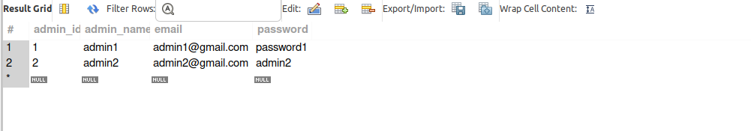**
2. **Products  
   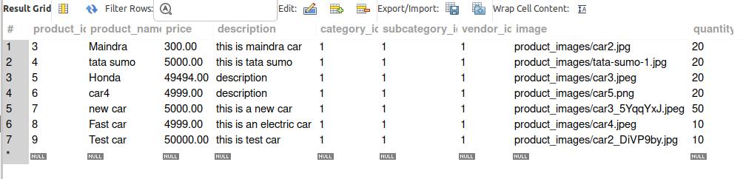**
3. **Customers  
   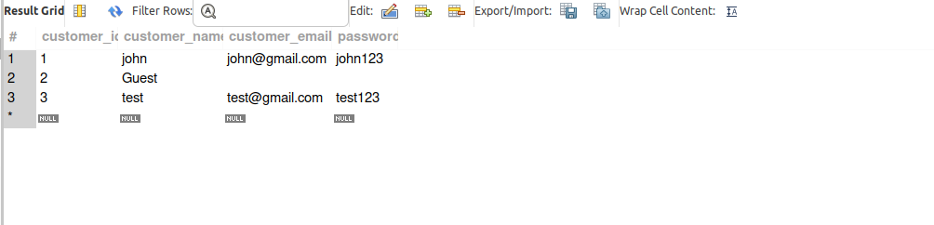**
4. **Categories  
   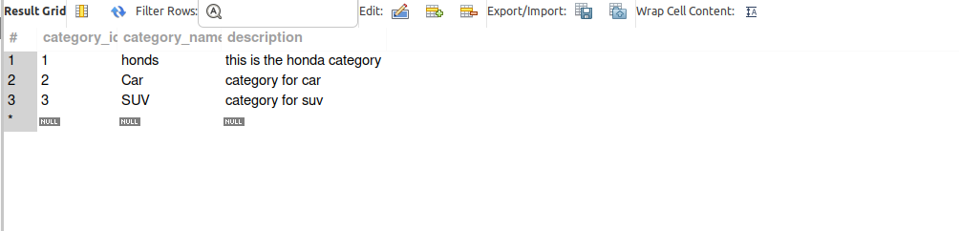**
5. **subCategories  
   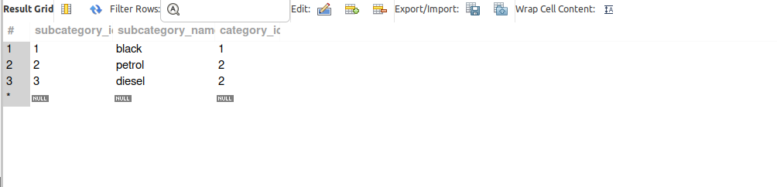**
6. **Cart  
   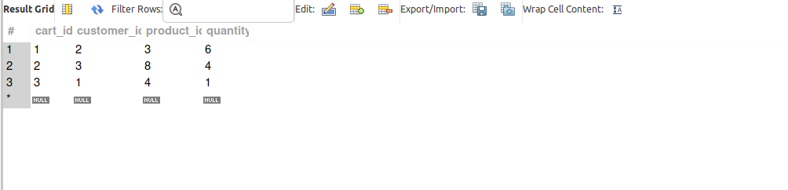**
7. **Reviews  
   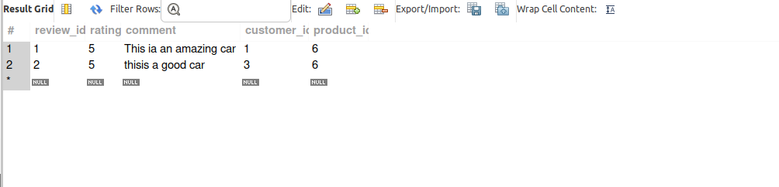**
8. **Shipping address  
   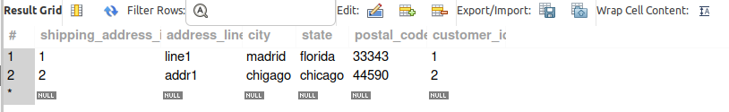**
9. **BIlling address  
   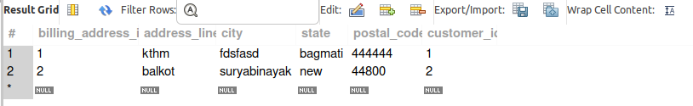**
10. **Payment gateways  
    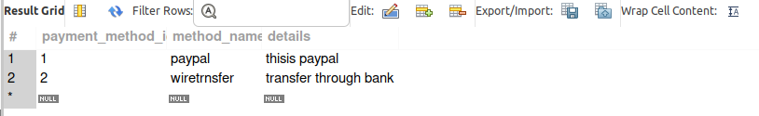**

**8. Functional Requirements and Queries  
a.Adding product**Admins can add the product through the system dashboard with details like category, subcategory, product name, price, quantity and image.  
  
Query:INSERT INTO product (vendor_id, category_id, subcategory_id, product_name, price, description, quantity, image)

VALUES (1, 1, 1, 'Example Product', 29.99, 'This is an example product description.', 50, 'example_product.jpg');

**b.Registering customers** Admin can add the customers who can sell and purchase the products from the system

Query:

INSERT INTO customer (customer_name, customer_email, password)

VALUES ('John Doe', 'john.doe@example.com', 'customer password');

**c. Adding the product to the cart**The system provides the functionality to add the product they want to buy to the shopping cart.

query:

INSERT INTO shoppingcart (customer_id, product_id, quantity)

VALUES (1, 1, 2);

**d.Vendor Registration**The system is capable of adding different vendors which sell different types of products.

Query:  
INSERT INTO vendor (vendor_name, vendor_email, password)

VALUES ('NewVendor', 'newvendor@email.com', 'newvendorpassword');

**9. Steps for running the system**Step 1: Download the Django project code to your local machine.  
Step 2: Make sure that Python and pip are installed on your machine.  
Step 3: Install the dependencies by using the command “**pip install -r requirements.txt”**.

Step 4: Open the project on any IDE and configure the database for MySQL in settings.py file.

DATABASES = {

'default': {

'ENGINE': 'django.db.backends.mysql',

'NAME': 'your_database_name',

'USER': 'your_database_user',

'PASSWORD': 'your_database_password',

'HOST': 'localhost',

'PORT': '3306',

}

}

Step 5: Create a superuser/admin by using the command “**python manage.py createsuperuser”**Step 6: Migrate the database using the command **“python manage.py migrate”**

Step 7: Run the development server using the command **“python manage.py run server”**Step 8: Access the system through the link **“**[**http://127.0.0.1:8000/**](http://127.0.0.1:8000/)**”.**Step 9: Access the admin through the link “[**http://127.0.0.1:8000/admin**](http://127.0.0.1:8000/admin)**”**

**10.UI Screenshots  
